Analyze and present the contribution of Alan Turing to AI.

Abstract:
Artificial Intelligence (AI) is one of the most transformative technologies of the modern world, influencing almost every sector including healthcare, education, defense, business, and communication. While AI appears to be a recent innovation, its conceptual and theoretical foundations were laid several decades ago. One of the most influential pioneers in this field is Alan Turing, whose groundbreaking ideas provided the mathematical and philosophical basis for artificial intelligence and computer science.
This report presents an in-depth analysis of Alan Turing’s life, his theoretical contributions such as the Turing Machine and the Turing Test, his wartime achievements, and his lasting influence on modern artificial intelligence. The report also discusses the ethical and philosophical relevance of his ideas in the present AI-driven era.
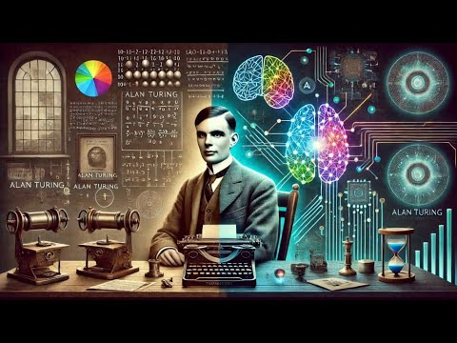

1. Introduction
Artificial Intelligence refers to the capability of machines to perform tasks that normally require human intelligence, such as learning, reasoning, problem-solving, decision-making, and language understanding. The development of AI has dramatically changed how humans interact with technology. However, the origin of AI is not rooted in modern computers alone, but in early theoretical thinking about intelligence and computation.
Alan Turing was among the first scientists to seriously explore whether machines could simulate human thinking. At a time when computers were either non-existent or extremely primitive, Turing imagined machines capable of processing symbols, following rules, and solving problems logically. His ideas transformed abstract mathematics into practical foundations for computing and artificial intelligence.
This report aims to study Turing’s contribution in detail and explain why his work remains central to AI research even today.
2. Historical Background and Early Life of Alan Turing
Alan Turing was a British mathematician, logician, and cryptanalyst who showed extraordinary intellectual abilities from a young age. He had a deep interest in mathematics, logic, and scientific reasoning. His academic journey exposed him to complex problems related to mathematical logic and decision-making processes.
During the early 20th century, mathematics was facing a major challenge: determining whether all mathematical problems could be solved using a fixed set of rules. Turing became deeply involved in this problem, which later led to the development of his most famous concept—the Turing Machine. His early work was not focused on artificial intelligence directly, but it eventually became the foundation upon which AI was built.
Turing’s curiosity about the nature of intelligence and computation placed him far ahead of his contemporaries. He believed that human thinking itself could be analyzed as a form of computation.
3. The Turing Machine: Theoretical Foundation of AI
3.1 Concept and Structure
The Turing Machine is a theoretical model that explains how a machine can perform computations using simple operations. It consists of an infinite tape divided into cells, a read/write head, and a set of rules that determine how symbols are processed.
Though it was never meant to be physically built, the Turing Machine proved that any computable problem can be solved using logical instructions. This concept became the theoretical backbone of modern computers
3.2 Importance in Artificial Intelligence
The significance of the Turing Machine to AI is immense. It established that machines could:
- Process information symbolically
- Follow logical steps to solve problems
- Simulate reasoning processes
All modern AI systems—whether machine learning models or decision-support systems—operate on computational principles derived from this idea. Without the Turing Machine, the concept of programmable intelligence would not exist.

4. Alan Turing and the Birth of Artificial Intelligence
Alan Turing was one of the first thinkers to directly question the nature of machine intelligence. He asked the revolutionary question:
“Can machines think?”
Rather than debating philosophical definitions of thinking, Turing proposed a practical approach: intelligence should be evaluated based on behavior. This idea became the cornerstone of artificial intelligence as a scientific field.
By shifting the focus from internal mental states to observable outcomes, Turing made it possible to design machines that could demonstrate intelligent behavior without needing consciousness or emotions.
5. The Turing Test: A Practical Measure of Intelligence
5.1 Explanation of the Turing Test
The Turing Test is an experiment designed to evaluate whether a machine can exhibit intelligent behavior indistinguishable from that of a human. In the test, a human evaluator interacts with both a human and a machine through text-based communication. If the evaluator cannot reliably tell them apart, the machine is considered intelligent.
5.2 Impact on AI Research
The Turing Test:
- Provided the first benchmark for machine intelligence
- Encouraged research in natural language processing
- Influenced chatbot and conversational AI development
- Sparked debates about the limits of machine intelligence
Even though modern AI evaluation methods have evolved, the Turing Test remains a historically important milestone.
6. Role in World War II and Its Technological Impact
During World War II, Alan Turing played a crucial role in cryptanalysis. He helped design machines that could decode encrypted military messages used by enemy forces. This work demonstrated the practical power of machines in solving highly complex logical problems.
6.1 Influence on Computing and AI
- Accelerated development of early computing machines
- Proved machines could outperform humans in certain tasks
- Established confidence in automated problem-solving
This wartime experience reinforced the idea that machines could handle intellectual tasks, a key principle in artificial intelligence.
7. Philosophical Contributions to Artificial Intelligence
Alan Turing’s work extended beyond mathematics into philosophy. He challenged the belief that intelligence is unique to humans and argued that machines should be evaluated objectively.
7.1 Intelligence as Observable Behavior
Turing believed that intelligence should be judged by what a system does rather than how it works internally. This idea is still widely used in AI evaluation and system design.
7.2 Ethical Implications
Turing’s ideas raised early ethical questions:
- What responsibilities do humans have toward intelligent machines?
- How should machine decisions be controlled?
- Can machines be trusted in critical tasks?
These questions are highly relevant in today’s AI-driven society.
8. Influence on Modern Artificial Intelligence Technologies
Modern artificial intelligence systems directly or indirectly rely on Turing’s ideas. His work influences:
Machine learning and data-driven intelligence
- Automated reasoning systems
- Natural language processing
- Cognitive computing models
Technologies such as virtual assistants, intelligent diagnostics, and autonomous systems are built upon principles he introduced decades ago.
9. Limitations and Criticism of Turing’s Ideas
- Although groundbreaking, Turing’s ideas have certain limitations:
- The Turing Test focuses mainly on language ability
- It does not measure emotional or moral intelligence
- Passing the test does not guarantee true understanding
However, these limitations encouraged further research and advancement in AI theory.
10. Relevance of Alan Turing in the Present Era
- Alan Turing’s contributions remain relevant because:
- AI systems still rely on computational logic
- Ethical concerns he raised are more important than ever
- His vision aligns with modern AI development
- He continues to inspire researchers, engineers, and philosophers worldwide.
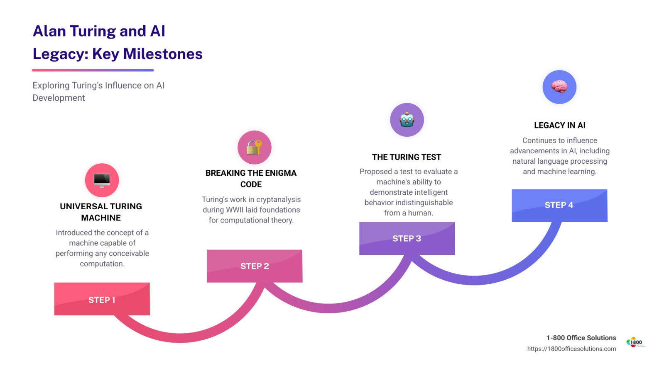
11. Conclusion
Alan Turing’s contribution to artificial intelligence is foundational and timeless. Through the Turing Machine, the Turing Test, and his philosophical insights, he transformed abstract ideas into practical tools for computing and machine intelligence. His work laid the groundwork for AI long before the technology existed to implement it fully.
In conclusion, Alan Turing can rightly be regarded as the father of artificial intelligence and computer science, whose ideas continue to shape the development, evaluation, and ethical understanding of intelligent machines in the modern world.

